
Shaheed Zulfikar Ali Bhutto Institute of Science & Technology
COMPUTER SCIENCE DEPARTMENT

TOTAL MARKS:
Shahee

OBTAIN MARKS:

ARTIFICIAL INTELLIGENCE

LAB PROJECT-II

TITLE: Inflation Rate Prediction In Pakistan Using Machine Learning

Submitted To: Sir Muhammad Ishfaq

Submission Date: 18 May 2026

Group Members Names: | Registration No
Laiba Ishaq | 2312121
Hira Hafeez | 2312119
Syed Murtaza Aali | 2312138

zooo

1. ABSTRACT:
This project presents a machine learning-based approach to predict inflation rates using Lasso Regression, a regularized linear model that performs both prediction and automatic feature selection. The model is trained using economic indicators such as manufacturing output, foreign direct investment, exchange rate, food imports, and military expenditure.
The system incorporates complete data preprocessing, feature scaling, model training using cross-validation, and an interactive user input interface for real-time prediction. The implementation ensures consistency, robustness, and practical usability aligned with real-world machine learning practices.

2. INTRODUCTION:
Inflation is one of the most significant economic indicators that affects the purchasing power of consumers, economic growth, and financial planning. Predicting inflation accurately helps governments, policymakers, economists, and businesses make informed decisions.
This project implements a Machine Learning-based Inflation Prediction System using the Lasso Regression algorithm. The model predicts inflation based on multiple economic indicators collected in an Excel dataset. The system reads historical economic data, preprocesses it, trains a regression model, evaluates prediction performance, and allows users to input economic values for inflation prediction.
Machine learning techniques are increasingly being used in economic forecasting because they can identify hidden patterns and relationships within historical data more effectively than traditional methods. By analyzing multiple economic indicators simultaneously, machine learning models can improve prediction accuracy and provide data-driven insights for decision-making. In this project, Lasso Regression is selected because it not only performs prediction but also helps identify the most influential variables affecting inflation by reducing the impact of less important features.
The project follows a systematic workflow that includes data cleaning, feature selection, data standardization, model training, testing, and performance evaluation using statistical metrics. Additionally, the system supports real-time prediction by allowing users to enter economic indicator values and generate inflation estimates based on the trained model.

3. PROBLEM STATEMENT:
Inflation is influenced by multiple economic variables and can fluctuate due to several macroeconomic factors. Traditional statistical methods often struggle with multicollinearity among economic indicators.
This project addresses the problem by using Lasso Regression, which:
- Performs regression
- Reduces overfitting
- Automatically selects important features
- Improves prediction accuracy

4. OBJECTIVES:
The main objectives of this project are:
- To predict inflation using historical economic data.
- To apply Lasso Regression for feature selection and prediction.
- To preprocess and standardize data for better model accuracy.
- To evaluate model performance using metrics such as:
  - Mean Squared Error (MSE)
  - R² Score
- To allow user-based prediction through console input.

5. DATASET DESCRIPTION:
The dataset is stored in an Excel file:
File Name: inflation_data.xlsx
The dataset contains historical economic indicators related to inflation.
Dataset Features:
The dataset includes:
Column | Description
Country Name | Country name
Country Code | Country abbreviation
Year | Observation year
Time Code | Time representation
Inflation | Target variable (Dependent Variable)
Manufacturing | Independent variable
Foreign Investment | Independent variable
Food Inflation | Independent variable
Official Exchange Rate | Independent variable
Military Expenditure (% GDP) | Independent variable
These variables represent major economic factors influencing inflation.

6. TECHNOLOGIES AND LIBRARIES USED:
The project is implemented in Python using the following libraries:
Library | Purpose
Pandas
 | Data loading and preprocessing
numpy | Numerical operations
Scikit-learn | Machine learning implementation

Imported Libraries:
- import pandas as pd
- import numpy as np
For Preprocessing:
- from sklearn.preprocessing import StandardScaler
For Train-Test Split:
- from sklearn.model_selection import train_test_split
For Machine Learning Model:
- from sklearn.linear_model import LassoCV
For Performance Evaluation:
- from sklearn.metrics import mean_squared_error, r2_score

7. METHODOLOGY:
The methodology explains the complete process followed to build the Inflation Prediction System using Lasso Regression. The project follows a step-by-step machine learning workflow, beginning from data collection and ending with inflation prediction.
Step 1. Data Collection:
The first step of the project is collecting historical economic data stored in an Excel file named:
inflation_data.xlsx
The dataset contains several economic indicators related to inflation across different years.
Some important variables in the dataset include:
- Inflation
- Manufacturing
- Foreign Investment
- Food Inflation
- Official Exchange Rate
- Military Expenditure (% of GDP)
These variables are used to train the machine learning model.
Purpose:
The purpose of collecting historical data is to help the model learn patterns and relationships between economic indicators and inflation.

Step 2. Data Preprocessing:
Raw datasets usually contain missing or incomplete values that can reduce model accuracy.
To solve this issue, missing values are removed using:
data = data.dropna()

Why this step is important?
- Removes incomplete records
- Prevents errors during model training
- Improves prediction reliability
After preprocessing, only clean and usable data remains.

Step 3. Feature Selection:
In machine learning, variables are divided into:
- Dependent Variable (Target Variable):
The dependent variable is the value we want to predict.
In this project:
Inflation is selected as the target variable.
dep_var = data.iloc[:, 4]
This means the model will learn how inflation changes based on economic indicators.

- Independent Variables (Input Features):
Independent variables are factors that influence inflation.
The following columns are selected:
indep_vars = data.iloc[:, 5:10]
These variables include economic indicators such as:
- Manufacturing
- Foreign Investment
- Food Inflation
- Exchange Rate
- Military Expenditure
Purpose:
These variables are used to help the model predict inflation.

Step 4. Data Standardization:
The selected features have different numerical scales.
For example:
Variable | Example Value
Food Inflation | 12
Exchange Rate | 200
Foreign Investment | 0.5
Because of these differences, the model may become biased toward larger numbers.
To solve this problem, StandardScaler is used.
scaler = StandardScaler()
indep_scaled = scaler.fit_transform(indep_vars)
Standardization converts all values to the same scale.
Why standardization is needed?
- Makes data consistent
- Improves model accuracy
- Prevents large-value variables from dominating smaller ones
- Helps faster learning
After scaling, all variables contribute equally during training.

Step 5. Splitting The Dataset:
The cleaned and standardized data is divided into two parts:
- Training Data (80%):
Used to teach the model.
- Testing Data (20%):
Used to evaluate model performance.
Code used:
train_test_split(
indep_scaled,
dep_var.values,
test_size=0.2,
random_state=123
)

Why split the data?
If the model is tested using the same data it learned from, results may be misleading.
Using separate testing data helps check:
- How accurately the model predicts unseen data
- Whether the model generalizes well

Step 6. Model Selection:
The project uses Lasso Regression, which is a machine learning algorithm used for prediction and feature selection.
lasso_model = LassoCV(
alphas=np.logspace(-6, 2, 100),
cv=5
)

Why Lasso Regression?
Lasso Regression was selected because it:
1. Predicts numerical values
Inflation is numerical, so regression is suitable.
2. Reduces overfitting
The model avoids memorizing data too closely.
3. Performs feature selection
Less important variables receive very small or zero importance automatically.
4. Improves model performance
Helps make predictions more stable.

Cross Validation (CV = 5):
The model uses:
cv = 5
This means the dataset is divided into 5 parts.
The model trains and tests itself 5 times using different combinations of data.
Purpose Of Cross Validation:
- Reduces bias
- Improves reliability
- Helps select the best model settings automatically

Step 7. Model Training:
After selecting the algorithm, the model is trained using training data.
lasso_model.fit(x_train, y_train)

What happens during training?
The model studies relationships between economic indicators and inflation.
For example, it learns patterns such as:
- How inflation changes with food prices
- The effect of exchange rate changes
- The impact of foreign investment
The model automatically finds the best alpha value (regularization parameter) for accurate prediction.

Step 8. Model Testing and Prediction:
Once training is complete, the model is tested using unseen testing data.
y_pred = lasso_model.predict(x_test)

Purpose:
To compare predicted inflation with actual inflation values.
This step checks whether the model performs well on new data.

Step 9. Model Performance Evaluation:
The model performance is measured using two evaluation metrics.
- Mean Squared Error (MSE):

mean_squared_error(y_test, y_pred)
MSE measures prediction error.
- Lower MSE = Better performance
- Higher MSE = Larger prediction mistakes
Purpose:
To determine how close predictions are to actual values.

B. R² Score:

r2_score(y_test, y_pred)
R² measures prediction accuracy.
R² Value | Meaning
1 | Perfect prediction
Above 0.7 | Good model
Near 0 | Weak prediction
Negative | Poor model
Purpose:
To evaluate how well the model explains inflation changes.

Step 10. User Input For Prediction:
After training, the system allows users to enter new economic values manually.
Example:
Food Inflation = 12
Exchange Rate = 180
Foreign Investment = 0.7
The program validates user input to ensure values remain within the dataset range.
if min_val <= value <= max_val

Why validation is important?
- Prevents unrealistic values
- Avoids prediction errors
- Improves system reliability

Step 11. Inflation Prediction:
The entered values are first standardized using the same scaler:
user_scaled = scaler.transform(user_df)
Then the trained Lasso model predicts inflation:
prediction = lasso_model.predict(user_scaled)
Finally, the predicted inflation result is displayed:
Predicted Inflation: X

8. METHODOLOGY WORKFLOW SUMMARY:
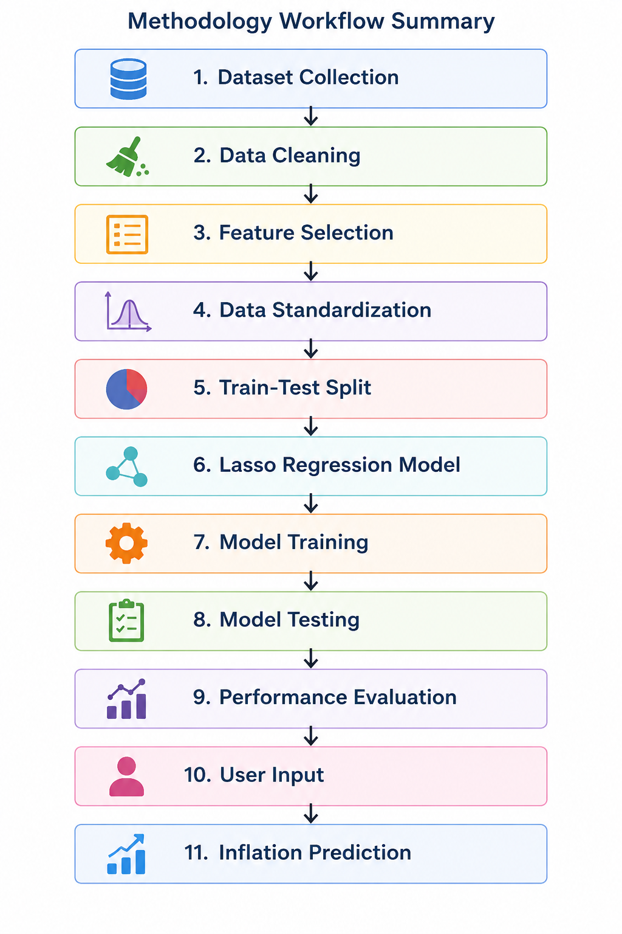

9. SYSTEM WORKFLOW:

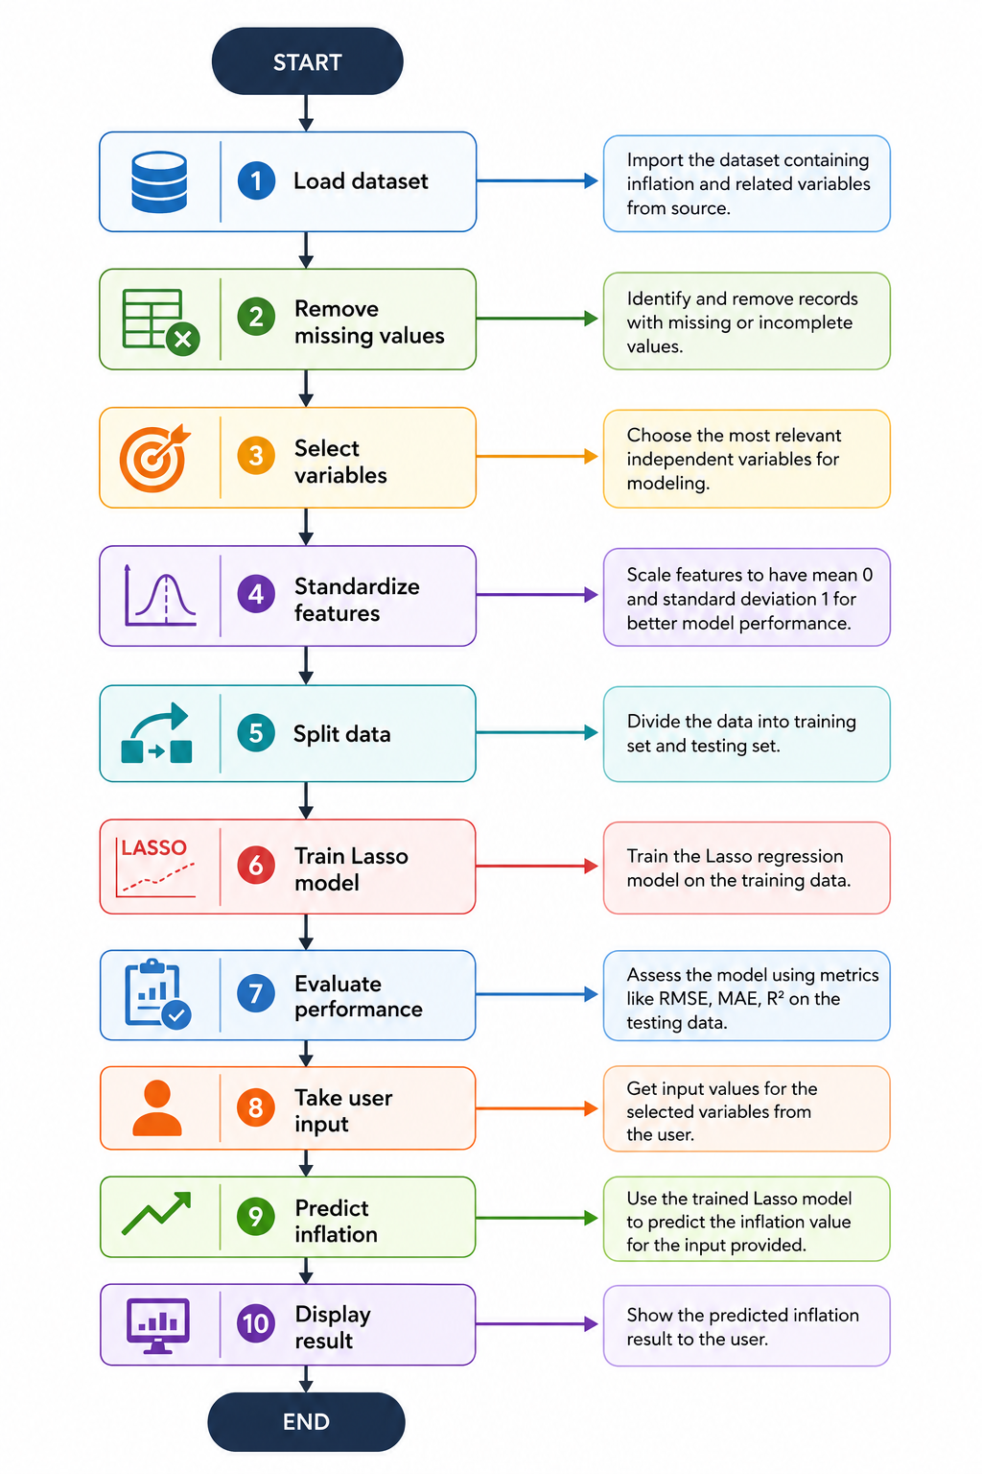

10. ADVANTAGES OF THE PROJECT:
- Uses machine learning for prediction.
- Handles overfitting using regularization.
- Performs feature selection automatically.
- Accepts real-time user input.
- Easy to extend with more variables.

11. LIMITATIONS:
- Prediction depends on dataset quality.
- Limited features may reduce accuracy.
- Works only for numerical inputs.
- Historical bias may affect future prediction.

12. Future Improvements:
Possible enhancements:
- Add graphical visualization.
- Build a web application using Flask/Django.
- Include more macroeconomic indicators.
- Compare multiple ML models:
  - Linear Regression
  - Random Forest
  - XGBoost
- Real-time economic data integration.

13. CONCLUSION:
This project successfully demonstrates the use of Lasso Regression for inflation prediction using historical economic indicators. The model preprocesses data, trains using standardized features, evaluates performance, and predicts inflation from user-provided values.
By applying machine learning techniques, the system provides a structured and scalable solution for economic forecasting and can be improved further for real-world applications.
The findings of this project highlight the importance of data-driven approaches in understanding economic trends and supporting informed decision-making. Although the model is developed using a limited set of economic indicators, it provides a strong foundation for predictive analysis in economics. With the inclusion of larger datasets, additional macroeconomic variables, and advanced machine learning techniques, the system can achieve higher accuracy and become more effective for practical forecasting purposes.

14. CODE:
# Import libraries
import pandas as pd
import numpy as np

from sklearn.preprocessing import StandardScaler
from sklearn.model_selection import train_test_split
from sklearn.linear_model import LassoCV
from sklearn.metrics import mean_squared_error, r2_score

# Load dataset
file_path = "inflation_data.xlsx"
data = pd.read_excel(file_path)

# Remove missing values
data = data.dropna()

# Select dependent and independent variables
dep_var = data.iloc[:, 4]
indep_vars = data.iloc[:, 5:10]

indep_names = indep_vars.columns

# Standardize independent variables
scaler = StandardScaler()
indep_scaled = scaler.fit_transform(indep_vars)

# Split data into training and testing
x_train, x_test, y_train, y_test = train_test_split(
indep_scaled,
dep_var.values,
test_size=0.2,
random_state=123
)
# Train Lasso Regression model
lasso_model = LassoCV(
alphas=np.logspace(-6, 2, 100),
cv=5
)

lasso_model.fit(x_train, y_train)

# Show training result
print("\nModel Trained Successfully (Lasso Regression)")
print("Best Alpha:", lasso_model.alpha_)

# Test the model
y_pred = lasso_model.predict(x_test)

# Check model performance
mse = mean_squared_error(y_test, y_pred)
r2 = r2_score(y_test, y_pred)

print("\nModel Performance:")
print("MSE:", mse)
print("R2 Score:", r2)

# Take input from user
print("\nEnter values for prediction:\n")

user_inputs = []

for col in indep_names:
min_val = indep_vars[col].min()
max_val = indep_vars[col].max()

while True:
try:
value = float(input(f"{col} ({min_val:.2f} to {max_val:.2f}): "))
if min_val <= value <= max_val:
user_inputs.append(value)
break
else:
print("Value out of range. Try again.")
except:
print("Invalid input. Enter a number.")

# Convert user input to dataframe
user_df = pd.DataFrame([user_inputs], columns=indep_names)

# Apply same scaling to user input
user_scaled = scaler.transform(user_df)

# Predict inflation
prediction = lasso_model.predict(user_scaled)

# Show final result
print("\n---------------------------------")
print("Predicted Inflation:", prediction[0])
print("---------------------------------")
# End program
input("\nPress Enter to exit...")

15.OUTPUT:
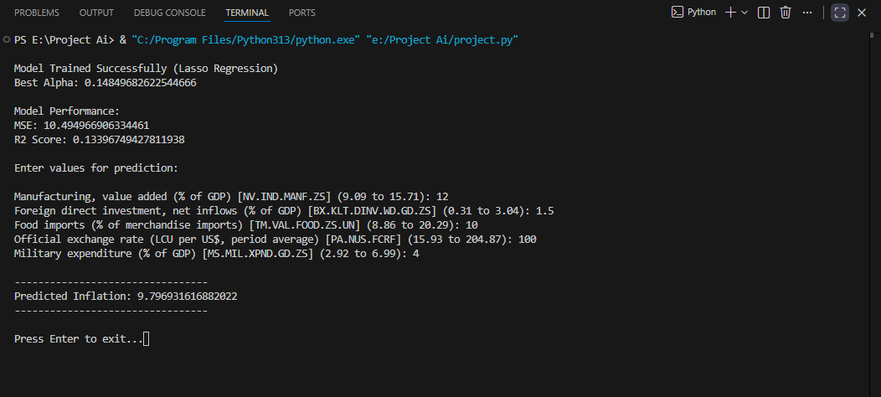

16. DATASET:
Country Name | Country Code | Time | Time Code | Inflation, consumer prices (annual %) [FP.CPI.TOTL.ZG] | Manufacturing, value added (% of GDP) [NV.IND.MANF.ZS] | Foreign direct investment, net inflows (% of GDP) [BX.KLT.DINV.WD.GD.ZS] | Food imports (% of merchandise imports) [TM.VAL.FOOD.ZS.UN] | Official exchange rate (LCU per US$, period average) [PA.NUS.FCRF] | Military expenditure (% of GDP) [MS.MIL.XPND.GD.ZS]
Pakistan | PAK | 2022 | YR2022 | 19.87385996 | 13.75863386 | 0.3899807535 | 13.20919413 | 204.8671875 | 3.162974521
Pakistan | PAK | 2021 | YR2021 | 9.496210561 | 11.93471622 | 0.6160394391 | 12.86849895 | 162.9062537 | 3.391711681
Pakistan | PAK | 2020 | YR2020 | 9.739993139 | 11.41607343 | 0.6846952899 | 14.99380499 | 161.8384797 | 3.48667909
Pakistan | PAK | 2019 | YR2019 | 10.5783618 | 12.58727459 | 0.6961464804 | 10.73618553 | 150.0362538 | 3.505840316
Pakistan | PAK | 2018 | YR2018 | 5.078057259 | 11.60274316 | 0.4877457507 | 10.03770896 | 121.8240689 | 3.586961764
Pakistan | PAK | 2017 | YR2017 | 4.08537368 | 11.29934591 | 0.7358370497 | 11.80993043 | 105.4551621 | 3.364449103
Pakistan | PAK | 2016 | YR2016 | 3.765119164 | 11.21091675 | 0.8213499981 | 12.50835057 | 104.769117 | 3.203776716
Pakistan | PAK | 2015 | YR2015 | 2.529328173 | 12.30144209 | 0.557734356 | 12.09752334 | 102.7692716 | 3.162986645
Pakistan | PAK | 2014 | YR2014 | 7.189384028 | 13.41402629 | 0.6953081168 | 11.72852878 | 101.1000884 | 3.096579697
Pakistan | PAK | 2013 | YR2013 | 7.692156119 | 13.32076285 | 0.5153538493 | 10.20374491 | 101.6288992 | 3.088020035
Pakistan | PAK | 2012 | YR2012 | 9.682351861 | 13.73907621 | 0.3434530487 | 11.05996232 | 93.39519722 | 3.095773537
Pakistan | PAK | 2011 | YR2011 | 11.91609271 | 13.38113593 | 0.5750551458 | 11.94970953 | 86.34338333 | 2.919243184
Pakistan | PAK | 2010 | YR2010 | 12.93887056 | 13.03550037 | 1.027911081 | 13.044965 | 85.19381633 | 3.041893265
Pakistan | PAK | 2009 | YR2009 | 13.64776506 | 12.53946637 | 1.248013055 | 11.3416776 | 81.71289167 | 3.265223993
Pakistan | PAK | 2008 | YR2008 | 20.28612109 | 13.25628901 | 2.689366561 | 11.85046959 | 70.40803333 | 3.459371004
Pakistan | PAK | 2007 | YR2007 | 7.598684411 | 12.48148456 | 3.035719338 | 8.863541635 | 60.73851583 | 3.5119861
Pakistan | PAK | 2006 | YR2006 | 7.921084401 | 12.61423338 | 2.639750062 | 10.2590317 | 60.271335 | 3.645255204
Pakistan | PAK | 2005 | YR2005 | 9.06332737 | 11.76255638 | 1.515750831 | 10.40091343 | 59.514475 | 3.897019393
Pakistan | PAK | 2004 | YR2004 | 7.444624693 | 10.45295151 | 0.8455857016 | 10.00146149 | 58.25786333 | 3.956034117
Pakistan | PAK | 2003 | YR2003 | 2.914134701 | 9.557900858 | 0.4752077118 | 11.28706972 | 57.75199667 | 4.091427187
Pakistan | PAK | 2002 | YR2002 | 3.290344726 | 9.373964074 | 0.8435173001 | 11.88237165 | 59.72378167 | 4.073770168
Pakistan | PAK | 2001 | YR2001 | 3.148261446 | 9.505079703 | 0.3891065865 | 12.20887971 | 61.92716167 | 3.878933945
Pakistan | PAK | 2000 | YR2000 | 4.366664513 | 9.094197863 | 0.3095950263 | 13.76728194 | 53.6481865 | 4.168722714
Pakistan | PAK | 1999 | YR1999 | 4.142637181 | 14.41352528 | 0.8447950066 | 16.36689555 | 49.50069158 | 5.189899265
Pakistan | PAK | 1998 | YR1998 | 6.228004154 | 14.68258059 | 0.8136100455 | 20.28508511 | 45.04666667 | 5.415095044
Pakistan | PAK | 1997 | YR1997 | 11.37549289 | 14.56036127 | 1.14722858 | 18.57495504 | 41.111525 | 5.621216489
Pakistan | PAK | 1996 | YR1996 | 10.37380859 | 14.60800604 | 1.456054495 | 14.8156869 | 36.07868333 | 6.037166305
Pakistan | PAK | 1995 | YR1995 | 12.34357852 | 14.61781361 | 1.19175194 | 17.50423865 | 31.64268333 | 5.820225283
Pakistan | PAK | 1994 | YR1994 | 12.36819439 | 15.70608805 | 0.8051189411 | 15.23 | 30.56659167 | 5.923548293
Pakistan | PAK | 1993 | YR1993 | 9.97366476 | 15.44935299 | 0.6727600119 | 14.21814615 | 28.10718333 | 6.427312623
Pakistan | PAK | 1992 | YR1992 | 9.509041462 | 15.42300755 | 0.6883136241 | 15.07939671 | 25.08279167 | 6.698187549
Pakistan | PAK | 1991 | YR1991 | 11.79127034 | 15.56339408 | 0.5663837373 | 12.15745616 | 23.80076667 | 6.570952788
Pakistan | PAK | 1990 | YR1990 | 9.052131553 | 15.46002479 | 0.6129976619 | 17.35378521 | 21.707375 | 6.522320235
Pakistan | PAK | 1989 | YR1989 | 7.844264737 | 14.7473514 | 0.5242572003 | 14.5683 | 20.54149167 | 6.532725256
Pakistan | PAK | 1988 | YR1988 | 8.837937018 | 14.94205562 | 0.4847368389 | 14.24422 | 18.00329167 | 6.785810731
Pakistan | PAK | 1987 | YR1987 | 4.681218546 | 14.99618327 | 0.3879211731 | 13.80618117 | 17.3988 | 6.971880084
Pakistan | PAK | 1986 | YR1986 | 3.506414248 | 14.74757644 | 0.3314527089 | 17.84973459 | 16.64750833 | 6.991656011
Pakistan | PAK | 1985 | YR1985 | 5.614839218 | 14.31642441 | 0.4218641393 | 18.88957157 | 15.92839167 | 6.922133598

